outcome 1

**TITLE** Investigate why the label extension does not work in ScandiPWA

**WHY?**We need to check what exactly is not working, so we know what to fix. It can be admin, saving data, GraphQL, or front-end.

**TODO**

* Try to upload label images in admin and check if they stay saved after refreshing the page.
* Check if the label field appears on the product edit page and if the product saves the selected label.
* Check database or Magento admin to confirm that labels are saved correctly.
* Open PLP and PDP in ScandiPWA and see if any label appears.
* Check if GraphQL returns label data at all (maybe there is no resolver).

**CONTENT** Main things we need to confirm:

* labels can be uploaded,
* labels can be assigned to a product,
* the data is saved correctly,
* ScandiPWA gets or doesn’t get this data via GraphQL.

**VISUALS / WIREFRAMES** Add 2–3 screenshots:

* admin label list,
* product edit page with label field,
* PLP or PDP where the label is missing.

**HOW TO TEST**

1. Upload a test label in admin.
2. Assign this label to a test product.
3. Open PLP and PDP in ScandiPWA and check if the label appears.

outcome 2

### **TITLE**

Add product label data to GraphQL for ScandiPWA

### **WHY?**

ScandiPWA gets all product information through GraphQL. If our label data is not in the API, the front-end can’t show it.

### **TODO**

* Add a GraphQL field for product labels (if it doesn’t exist yet).
* Make a simple resolver that returns label image and label name for each product.
* Make sure product list (PLP) and single product (PDP) queries include this new field.

### **CONTENT**

We just need the front-end to receive:

* label image URL,
* label name,
* no errors if the product has no label.

### **VISUALS / WIREFRAMES**

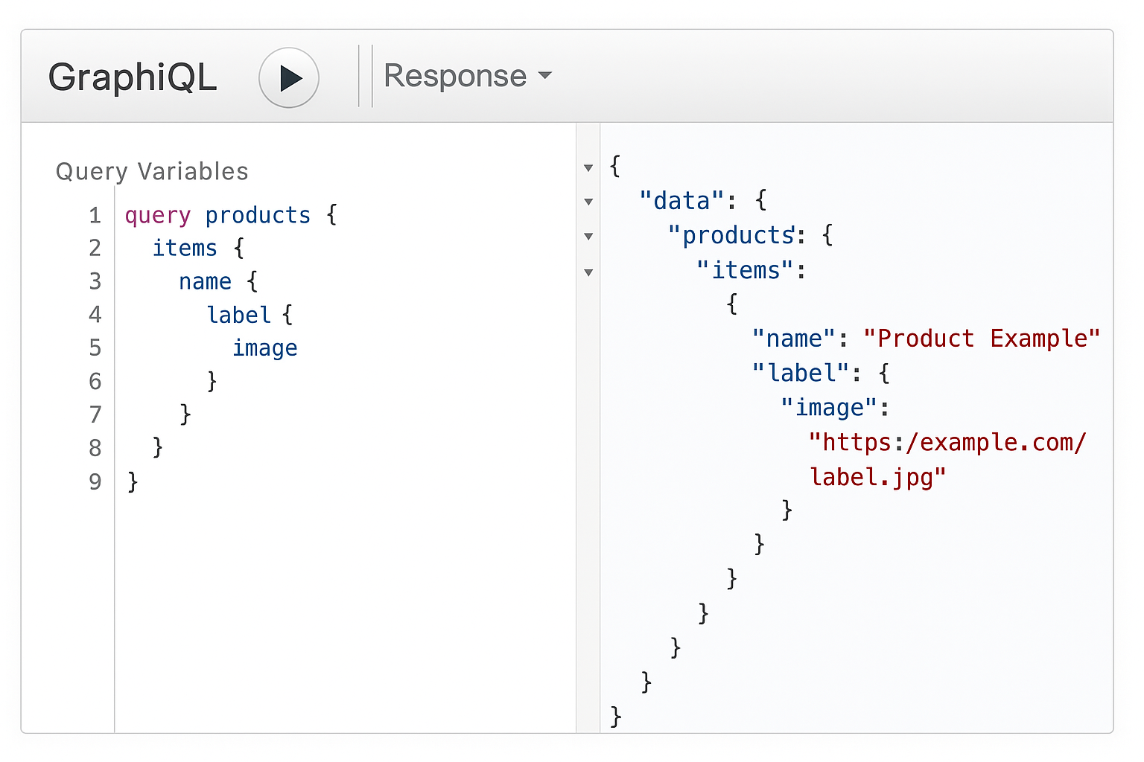

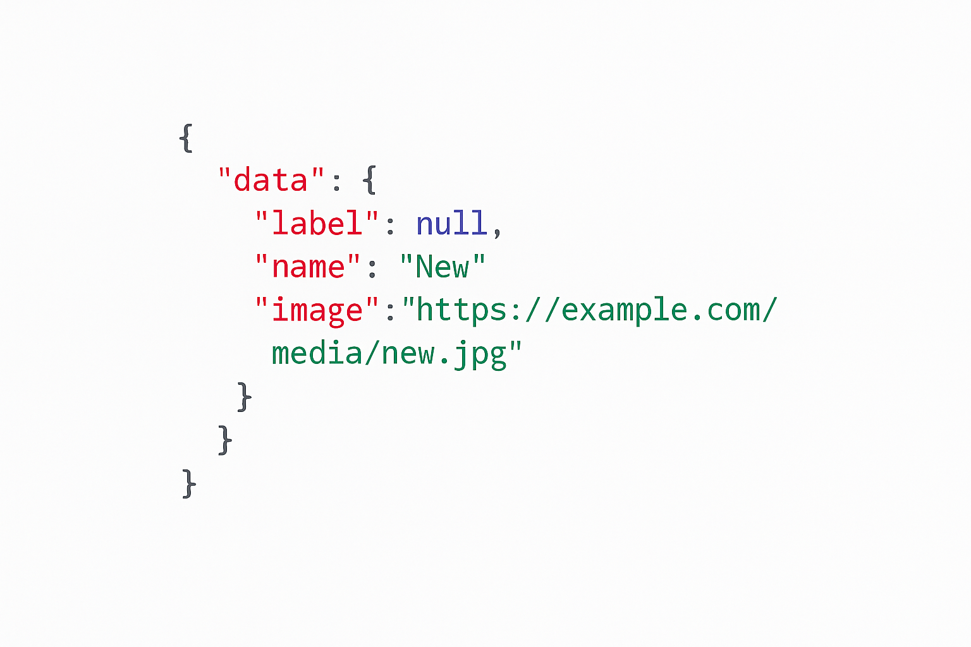

### **HOW TO TEST**

1. Assign a label to a test product in admin.
2. Run a GraphQL query for product list and single product.
3. Make sure label data appears in the response.
4. Test product with no label — the API should return null or empty, but no errors.

### **TITLE**

Display product labels on PLP and PDP in ScandiPWA

### **WHY?**

Even if GraphQL returns label data, users will not see it until the UI shows it. We need a small label on PLP and a bigger one on PDP.

### **TODO**

* Update the PLP product card to show a small label image on top of the product image.
* Update the PDP main image area to show a larger label.
* Add simple styles so the label looks clean and does not break layout.
* Only show a label if the product has one.

### **CONTENT**

* PLP → small badge on product image
* PDP → larger badge on main product image
* Labels should overlay the image using simple absolute positioning

### **VISUALS / WIREFRAMES**

### **HOW TO TEST**

1. Create three test products:  
   * one with a “New” label,
   * one with a “Sale” label,
   * one with no label.
2. Open the PLP:  
   * “New” and “Sale” products should show a small label,
   * products without labels should show nothing.
3. Open the PDP:  
   * labels should appear in a larger size on the main image.
4. Check layout on desktop and mobile to make sure nothing overlaps or breaks.